October | 2019
Monday | Tuesday | Wednesday | Thursday | Friday
Thanksgiving Turkey Applications will be taken during the month of October!!!!  See Dates. | 1 | 2  Zumba Gold 12p - 1p  Weight Management Series Class # 4 1p – 2p | 3 | 4
7 | 8 | 9 | 10 | 11
FLYY FITNESS!!  Zumba and Mindfulness 11a - 12p  Turkey Applications in Lobby 11a-1p |  | Zumba Gold 12p - 1p  Weight Management Series Class #5 1p – 2p  Turkey Applications in Lobby 11a-1p
14  Foodshare Mobile Site  225 Washington St. 8:30a – 9:30a  FLYY FITNESS!!  Zumba and Mindfulness 11a - 12p  Turkey Applications in Lobby 11a-1p | 15 | 16  Zumba Gold 12p - 1p  FAT Attack Class with Community Health Network Educator 1PM  Turkey Applications in Lobby 11a-1p | 17 | 18  Paint Class  11a - 2p  If planning to participate, please call a CHW to register. Limited to 23.
21  FLYY FITNESS!!  Zumba and Mindfulness 11a - 12p  Turkey Applications in Lobby 11a-1p | 22 | 23  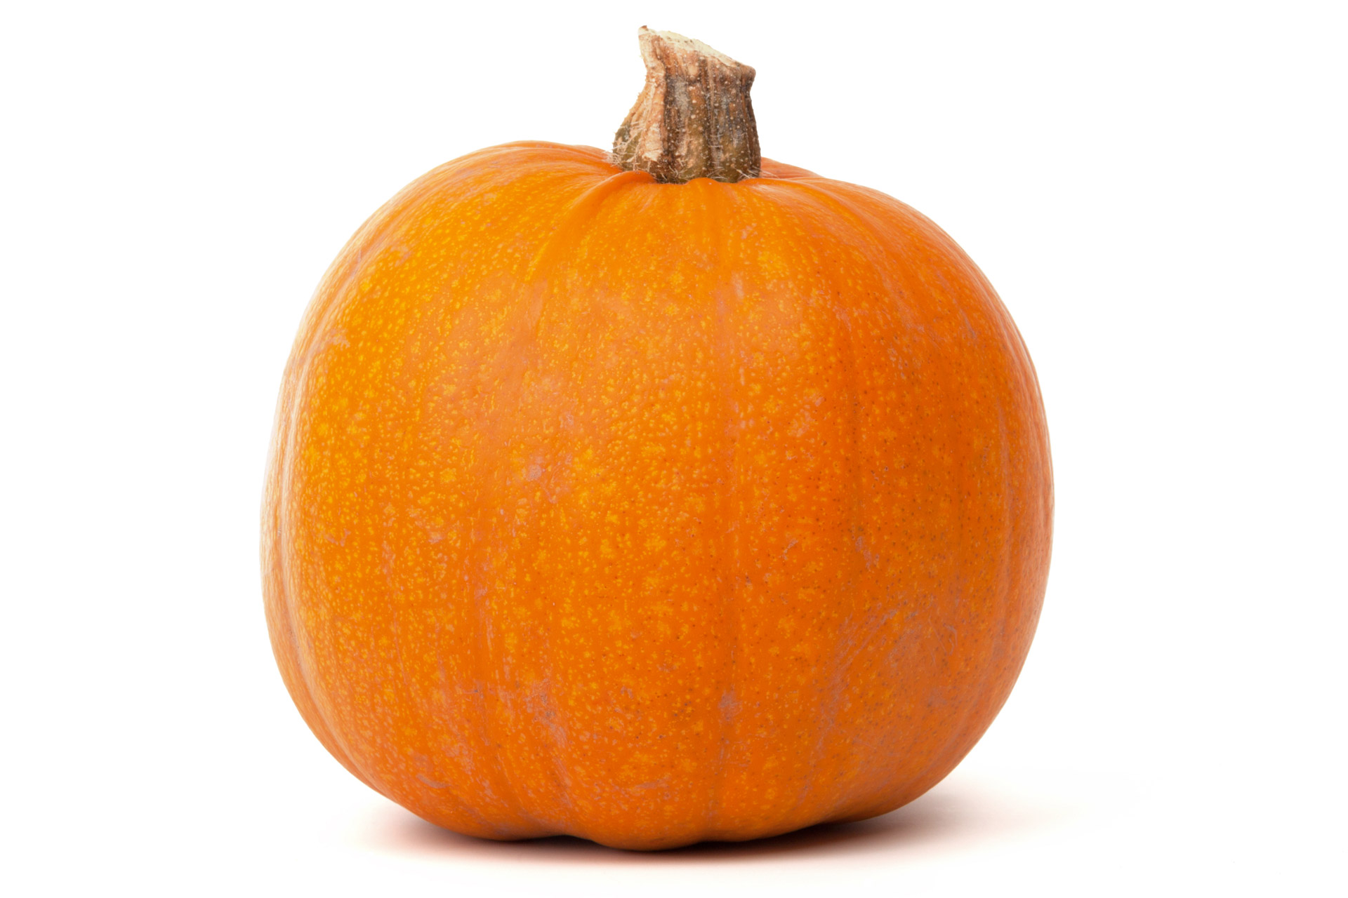  Zumba Gold 12p - 1p  Benefits of Pumpkins Class 1PM  Turkey Applications in Lobby 11a-1p | 24 | 25  Turkey Applications in Lobby 11a-1p
28  Foodshare Mobile Site  225 Washington St. 8:30a – 9:30a  FLYY FITNESS!!  Zumba and Mindfulness 11a - 12p | 29 | 30  Zumba Gold 12p - 1p  Weight Management Series Class # 6 1p – 2p | 31
All Nutrition Classes take place in Nutrition Department 4th floor
Food Share Mobile Site is located at 225 Washington Street / Salvation Army Parking Lot – ALL in need of food are welcome!

